Software Requirement Specification Document

For

Hospital Management System

Prepared by

Aniruddh Dwivedi

(23BCE8304)

School of Computer Science and Engineering



10th January 2025

Table of Contents

Page Numbers

1. Introduction
   1. Purpose
   2. Intended Customers/Users
   3. Product Scope
   4. Outline of the document
2. Overall Description
   1. Product Perspective
   2. Product Functions
   3. User Classes
   4. Design and Implementation Constraints
3. Diagrams
   1. UML Diagrams
   2. ER Diagrams
   3. DFD Diagrams
   4. Assumptions and Dependencies
4. External Interface Requirements/Screenshots
   1. User Interfaces
   2. Hardware Interfaces
   3. Software Interfaces
   4. Communication Interfaces
5. Other Non-Functional Requirements
   1. Performance Requirements
   2. Safety Requirements
   3. Security Requirements
   4. Software Quality Attributes
   5. Business Policies/Rules (if any)
6. Testing
   1. Block-Box Testing
   2. White-Box Testing
7. Conclusion
8. References
9. Acknowledgements
10. **Introduction**

This Software Requirement Specification Document for the development of a hospital entails the different aspects involved in the creation and optimization of the Hospital Management System.

* 1. Purpose

The purpose of the hospital management system is to help a hospital or any other large-scale patient care system to be enabled to store patient, employee, and transport records in an organized manner over the course of its operation.

* 1. Intended Customers/Users

The intended users of the designed system are hospital staff and human resources managers who would find themselves eased in their jobs through the use of the provided software product.

* 1. Product Scope

The Hospital Management System aims to streamline the operational and administrative processes within a hospital environment by providing a centralized, user-friendly platform for managing patient records, employee details, appointments, inventory, billing, and other critical hospital functions.

* 1. Outline of the document

The document provides an overview on the workings of the Hospital Management System, including its purpose, intended users, and scope. It outlines the overall description of the product, detailing its perspective, key functions, user classes, and design constraints. Visual representations such as UML, ER, and DFD diagrams are included to illustrate the system architecture and workflows, along with assumptions and dependencies.

1. Overall Description

The Hospital Management System is a standalone software designed to digitize and centralize hospital operations, integrating seamlessly with existing hospital infrastructure, providing a cohesive platform for managing patient records, staff data, appointments, billing, and more.

* 1. Product Perspective

The Hospital Management System is designed to digitize and centralize hospital operations. It integrates with existing hospital infrastructure to provide a cohesive platform for managing patient records, staff data, appointments, billing, inventory, and more. The system is designed to be scalable and readily accessible by different levels of technically inclined individuals.

* 1. Product Functions

The hospital management system provides the following key functions:

* **Patient Management:** Registration and appointment scheduling.
* **Staff Management:** Storing employee details and performance metrics.
* **Billing and Payments:** Automating billing processes and payment tracking.
* **Inventory Management:** Monitoring stock levels of medicines and medical supplies.
  1. User Classes

Three basic classes of users are decided to be availed to the system’s potential user-base, these are:

* Administrators: Monitor the use of the system by sub-classes of users and make executive decisions regarding hospital administrative processes
* Standard Employees: Manage the regular record maintenance of the system’s records.
* Technical Staff: Maintain the software and ensure data integrity.
  1. Design and Implementation Constraints

Data Security: Encryption and secure access are needed control mechanisms to protect sensitive data.

Hardware Limitations: The system must operate efficiently on existing hospital hardware.

Technical Expertise: Hospital staff may have limited technical knowledge, which may lead to them being unable to manage the workings of the system.

1. **Diagrams**
   1. UML Diagrams

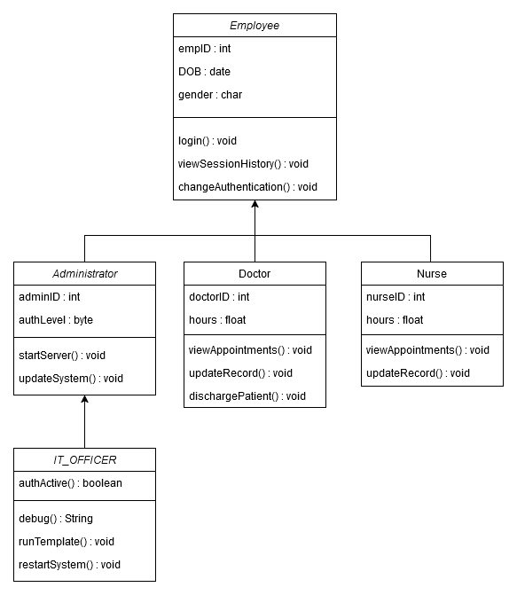3.1.1. Class-Diagram for representation of the system’s user profiles

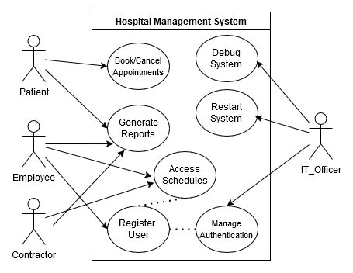

3.1.2. Use-Case diagram describing the different roles played by different user types

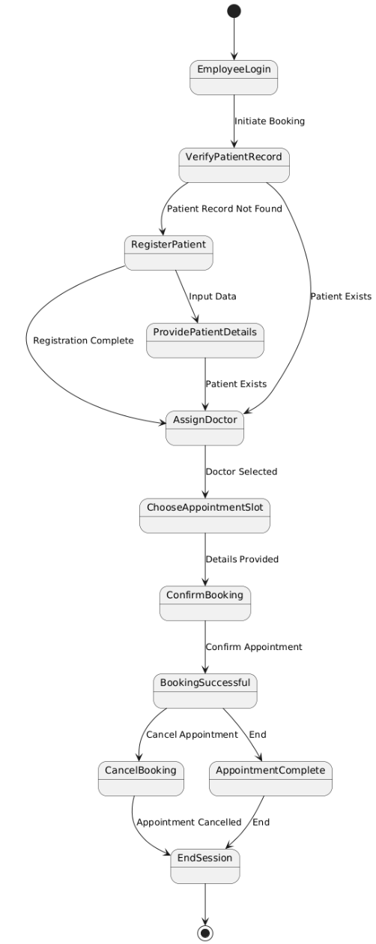

3.1.3. state-machine diagram describing the system’s patient booking interface

3.2. ER Diagrams

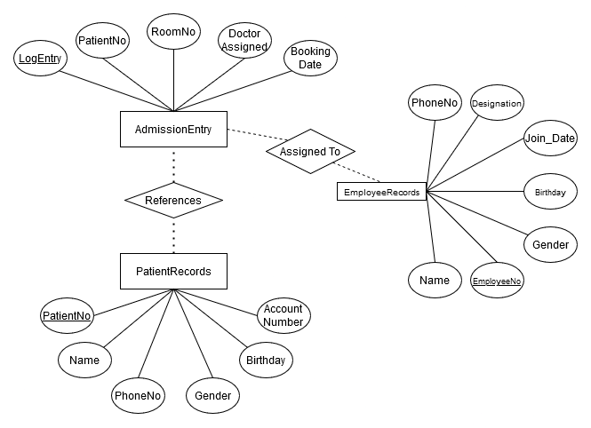

3.2.1. Chen’s ER diagram notation for patient record management

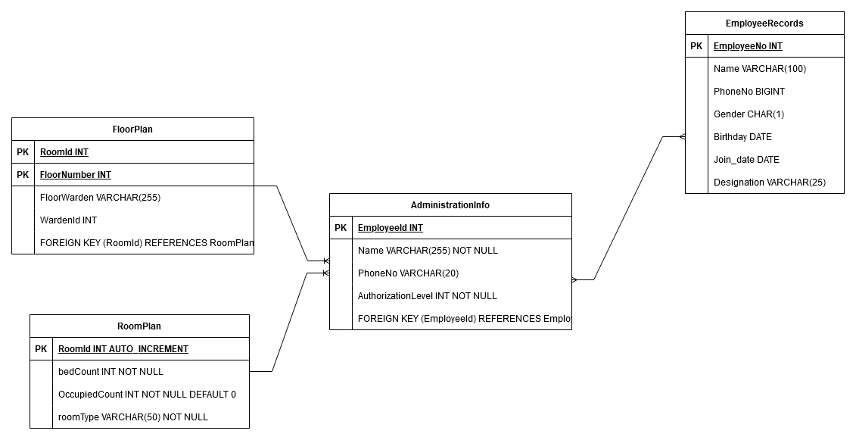

3.2.2. Barker’s ER diagram notation for Room Assignment Detail

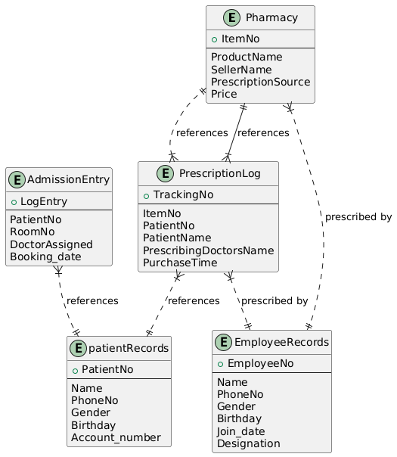 3.2.3. Crow’s Foot ER diagram for representing Pharmacy Records

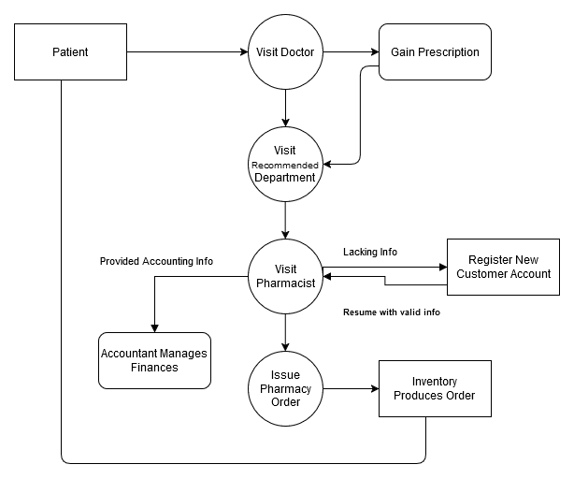3.3. DFD Diagrams

3.3.1. DFD diagram for representing Customer to Department interactions

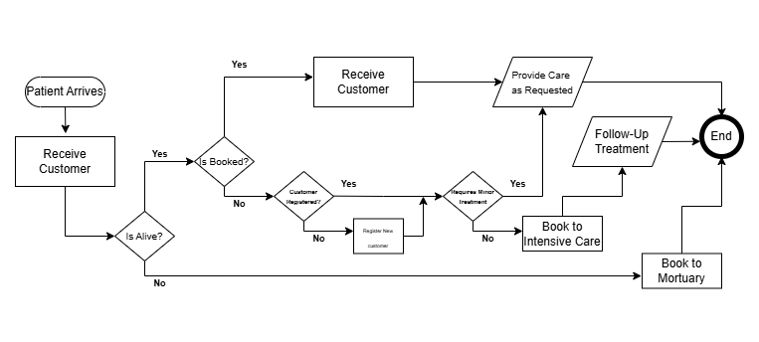

3.3.2. DFD diagram for representing Customer Intake Procedure

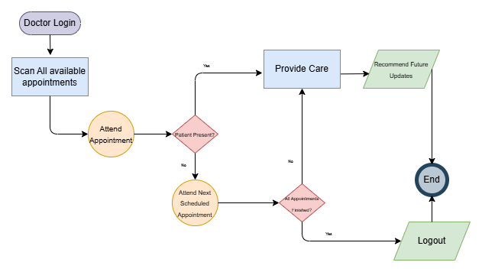

3.3.3. DFD diagram for representing Doctor’s daily work procedure

3.4. Assumptions and Dependencies

The current model of the system expects a decent level of technical know-how being available to all members of staff and may as such prove quite challenging to have to learn from scratch. The System relies on well-maintained infrastructure that must be regularly updated and be readily accessible for all members of staff at their respective authorization levels.